STUDENT PROGRESS TRACKER
@CREATIVITY THINK (9483175986/7019689991)

ABSTRACT:
The Student Progress Tracker is a dashboard-based web application designed to monitor and analyze student academic performance. Users, such as teachers, can input marks, view subject-wise and monthly performance charts, generate report cards, receive alerts, and export data. Administrators can manage classes and students, perform detailed analytics, and send alerts to parents. Built using Django and Django Rest Framework for backend operations and React with Chart.js and Axios for frontend visualization, the system ensures real-time performance monitoring, accurate reporting, and data-driven decision-making. This project enhances teaching efficiency, student performance tracking, and parental engagement..

INTRODUCTION OF THE PROJECT:
Tracking student progress is essential for schools and learning centers to identify academic strengths and weaknesses. The Student Progress Tracker provides teachers with tools to input marks, analyze subject-wise performance, and generate monthly and overall charts. Reports and alerts can be shared with parents to improve engagement. Administrators manage classes, students, and analytics through a centralized dashboard. Using Django for backend services and React with Chart.js for interactive charts, the system offers a scalable and user-friendly solution for real-time monitoring, reporting, and data-driven decision-making in educational institutions..

PROJECT OBJECTIVES:

• Develop a centralized platform for entering and tracking student marks
• Generate subject-wise, monthly, and overall performance charts
• Provide teachers with report cards and exportable analytics
• Send alerts to parents about performance and important updates
• Allow administrators to manage classes, students, and analytics
• Enable real-time visualization of student performance
• Improve decision-making for teachers and parents

PROBLEM OF THE STATEMENT:
Educational institutions often struggle to effectively monitor student performance due to manual record-keeping and scattered data. Teachers may face difficulties in analyzing subject-wise scores or generating overall performance reports. Parents may not receive timely updates about their child’s progress. Administrators often find it challenging to manage classes, students, and analytics efficiently. The Student Progress Tracker solves these issues by offering a centralized, real-time, and interactive dashboard system for entering marks, tracking performance, generating reports, sending alerts, and exporting data, ensuring better decision-making, communication, and academic outcomes..

MOTIVATION OF THE PROJECT:
• Improve academic performance tracking for students
• Provide teachers with actionable insights through charts
• Enable parents to stay informed via alerts and reports
• Streamline data management for administrators and educators
• Reduce manual effort in generating reports and performance analysis

BLOCK DAIGRAM OF PROJECT:

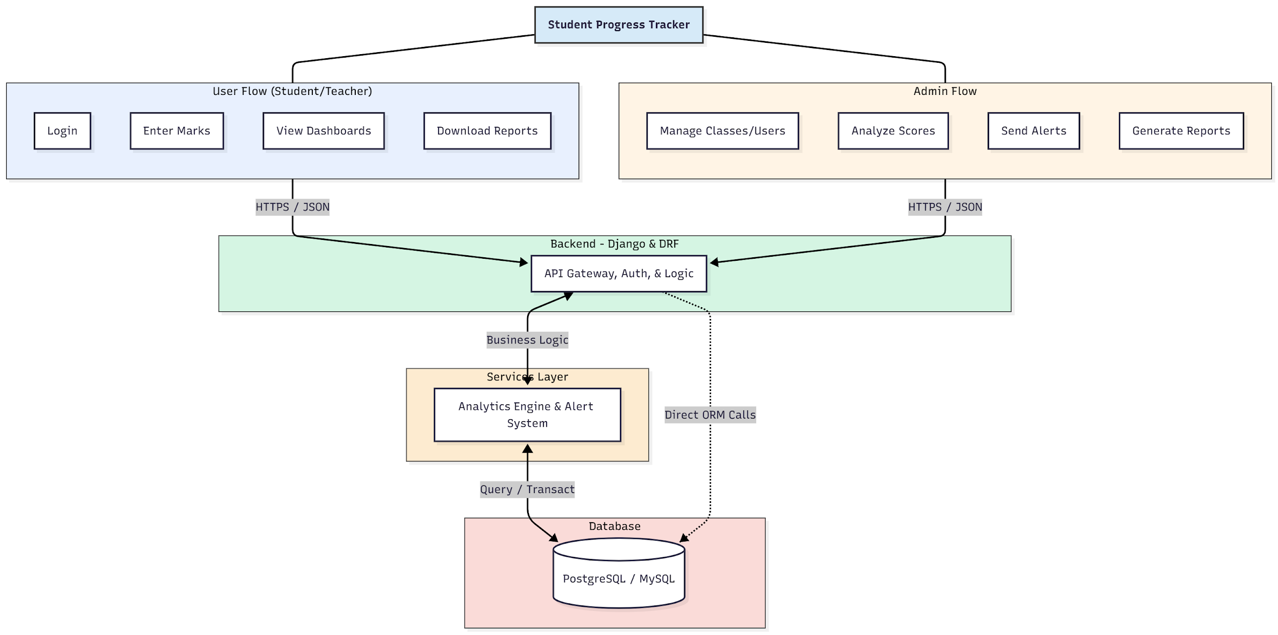

WORKING OF THE PROJECT:
Teachers log in to the Student Progress Tracker to input marks for students across different subjects. Subject-wise, monthly, and overall charts are generated automatically for performance analysis. Teachers can download report cards and send alerts to parents regarding student progress. The backend handles authentication, validation, and API requests, while the services layer processes analytics, generates charts, and manages alert notifications. Administrators oversee class management, student records, and generate comprehensive analytics reports. This integrated system ensures accurate tracking, visualization, and reporting of student performance, enhancing teaching efficiency and parental engagement..

SOFTWARE REQUIREMENT:
- Backend:
  - Python 3.x
  - Django
  - Django REST Framework
  - SQLite/PostgreSQL
- Frontend:
  - Node.js and npm
  - React.js
  - Axios
- Development Tools:
  - Visual Studio Code
  - Postman (for testing APIs)
  - Git/GitHub (for version control)
- Server/Deployment (Optional):
  - Gunicorn, Nginx, or Heroku/AWS for hosting

ADVANTAGES OF THE PROJECT:

• Centralized student performance tracking
• Automated subject-wise and overall performance charts
• Exportable report cards and analytics
• Alerts and notifications to parents
• Efficient management of classes and students
• Real-time dashboards for teachers and administrators
• Improved decision-making and academic planning
• Reduces manual effort in performance tracking

APPLICATIONS OF THE PROJECT:
• Schools and educational institutions
• Private tutors and coaching centers
• Learning and skill development centers
• Parent-teacher communication and progress tracking
• Academic performance analytics and reporting
• Data-driven student evaluation
• Tracking monthly and yearly academic trends
• Remote monitoring of student performance

REFERENCES:

- Django REST Framework Documentation — Django Software Foundation. Django Documentation. Available: https://docs.djangoproject.com/
- Django REST Framework. DRF Documentation. Available: https://www.django-rest-framework.org/
- React. React Official Documentation. Available: https://reactjs.org/docs/getting-started.html
- Redux. Redux Documentation. Available: https://redux.js.org/introduction/getting-started
- PostgreSQL Global Development Group. PostgreSQL Documentation. Available: https://www.postgresql.org/docs/
- MySQL. MySQL Reference Manual. Available: https://dev.mysql.com/doc/
- Git. Git Documentation. Available: https://git-scm.com/doc
- Node.js. Node.js Documentation. Available: https://nodejs.org/en/docs/
- Axios. Axios Documentation. Available: https://axios-http.com/docs/intro
- Socket.io Documentation – https://socket.io/docs/

